# 1st Asian Science and Technology Conference for Disaster Risk Reduction

*Science-policy dialogue for Implementaion of the Sendai Framework*

23- 24 August 2016, Bangkok, Thailand

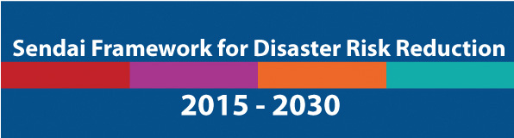

# Registration Form

Note: All fields are mandatory

Official government delegation Yes/No

Other delegation

___________________________________________________________________________

PARTICIPANT INFORMATION

Salutation: Mrs./ Ms./ Mr./Dr. ____________________________

First Name: ____________________________________________

Middle Name: ____________________________________________

Last Name: ____________________________________________

Gender: Male/ Female

Nationality: ____________________________________________

Blood Group: ____________________________________________

**DETAILS OF WORKPLACE**

Type of Organization: ________________________________________________________

Organization Name:__________________________________________________________

*(Please enter the full name of the organization where you work. If you work for a government, please provide details of the Department, Organization and Ministry, you work in.)*

Designation: ___________________________________________________

Work Email: ___________________________________________________

Confirm Work Email: ___________________________________________________

Phone Number (including Country calling codes):

Office: ______________________________ Residence: _____________________________

Mobile Number: ______________________ Fax: __________________________________

Organization Website: ________________________________________________________

ORGANIZATION ADDRESS

Street Address: ______________________________________________________________

___________________________________________________________________________

___________________________________________________________________________

Village/Town/City: _________________________Country: __________________________

Postal Code: ______________

Further information: Contact Mr. Surachai Srisa-ard (Nong), UNISDR-Asia and Pacific

[] Email: [srisa-ard@un.org](mailto:srisa-ard@un.org) [] Tel office: +66-2-288-1779